**Project Design Phase-II**

**Data Flow Diagram &User Stories**

|  |  |
| --- | --- |
| Date | 16 October 2022 |
| Team ID | PNT2022TMID44089 |
| Project Name | Web Phishing Detection |
| Maximum Marks | 4 Marks |

**Data Flow Diagrams:**

A Data Flow Diagram (DFD) is a traditional visual representation of the information flows within a system. A neat and clear DFD can depict the right amount of the system requirement graphically. It shows how data enters and leaves the system, what changes the information, and where data is stored.

Example: DFD Level 0 (Industry Standard)

**](https://developer.ibm.com/patterns/visualize-unstructured-text/)**

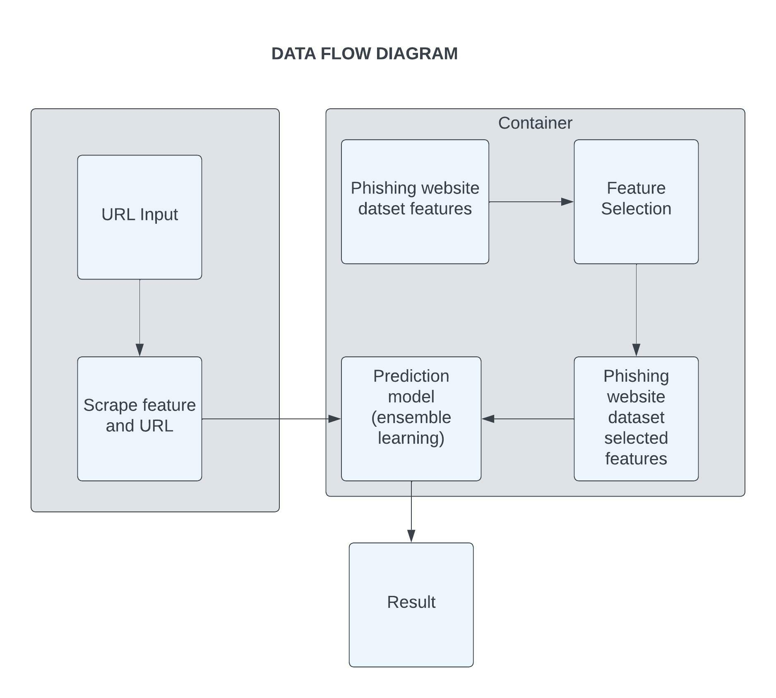

**User Stories**

Use the below template to list all the user stories for the product.

| **User Type** | **Functional Requirement (Epic)** | **User Story Number** | **User Story / Task** | **Acceptance criteria** | **Priority** | **Release** |
| --- | --- | --- | --- | --- | --- | --- |
| Customer (Mobile user) | Registration | USN-1 | As a user, I can register for the application by entering my email, password, and confirming my password. | I can access my account | High | Sprint-1 |
|  |  | USN-2 | As a user, I will receive confirmation email once I have registered for the application | I can receive confirmation email & click confirm | High | Sprint-1 |
|  |  | USN-3 | As a user, I can register for the application through Facebook | I can register & access the dashboard with Facebook Login | Low | Sprint-2 |
|  |  | USN-4 | As a user, I can register for the application through Gmail |  | Medium | Sprint-1 |
|  | Login | USN-5 | As a user, I can log into the application by entering email & password |  | High | Sprint-1 |
|  | Dashboard | USN-6 | As a user I have to search for a leakage of my personal data with some basic credentials. | An Interface identifying that is there any private and secured data leaked. | High | Sprint-1 |
| Customer (Web user) | Dashboard | USN-7 | As a web user I have to login to the website and search for leakage of my data | The parameters appear one by one | High | Sprint-1 |
| Customer Care Executive | Request page |  | As a customer care executive find the request and should help the customer with the problem | Response from customer | High | Sprint-1 |
| Administrator | Management |  | Manage all the requests and giving good output to the customers | Managing all the requests | Medium | Sprint-2 |
|  |  |  |  |  |  |  |
|  |  |  |  |  |  |  |
|  |  |  |  |  |  |  |